**Exercício 1**

**(a)**

T = {num, -, /}

V = {expr}

P = { expr -> expr - expr , expr-> expr/expr, expr->num }

S = expr

**(b)**

5/6-42

expr -> expr/expr-> num/expr-> num/expr-expr-> num/num-expr-> num/num-num

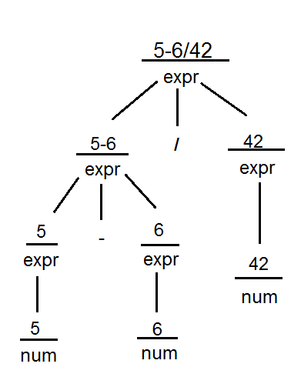

**Exercício 2**

**(a)**

T = {num, +, *, ()}

V = {expr}

P = { expr -> expr + expr , expr-> expr*expr, expr->(expr), expr->num }

S = expr

**(b)**

2+3*(5+6*8)

expr -> expr+expr -> expr+expr*expr-> expr+expr*(expr) -> expr+expr*(expr+expr) ->

expr+expr*(expr+expr*expr) -> num+expr*(expr+expr*expr) -> num+num*(expr+expr*expr) -> num+num*(num+expr*expr) -> num+num*(num+num*expr) -> num+num*(num+num*num)

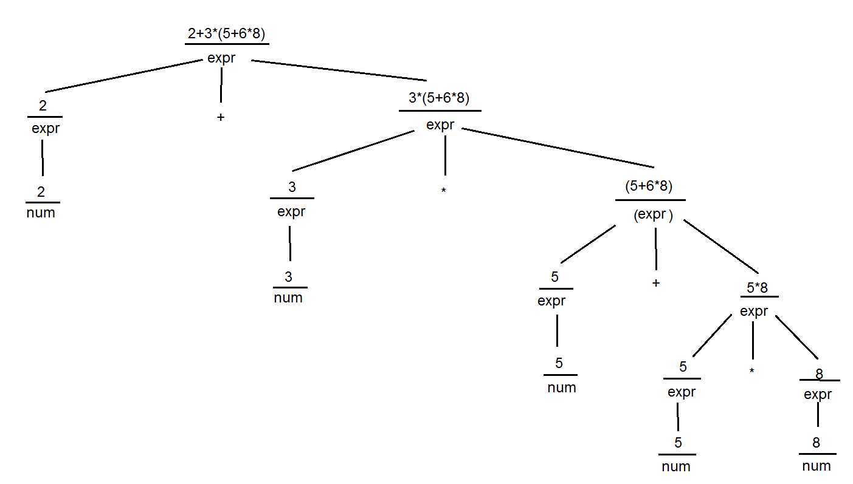

**Exercício 3**

E -> E a E

E -> a

Exemplo com cadeia **aaa**

1. E -> EaE -> aaE-> aaa
2. E-> EaE -> Eaa -> aaa

É ambígua pois possui duas arvores sintáticas para a cadeia **aaa**